For of and for in loops

# 

Map , filter and reduce methods

They are high order methods

Modern java script method and are used to save time

Map and foreach are same but Map method creates new array

WE USE MAP WHEN WE WANT To Create NEW ARRAY AND NORMALLY TO PERFORM OPERATION ON EACH ELEMEnt WE USE FOREACH LOOP

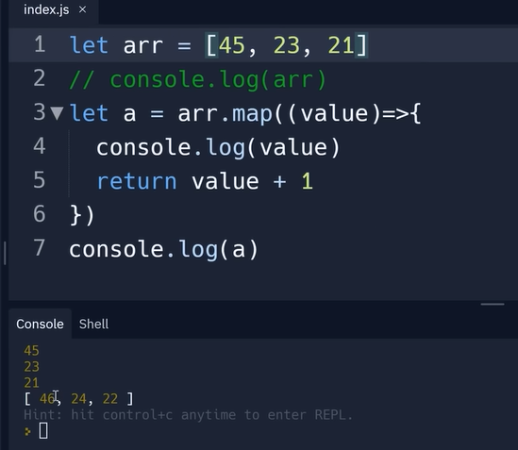

FILTER

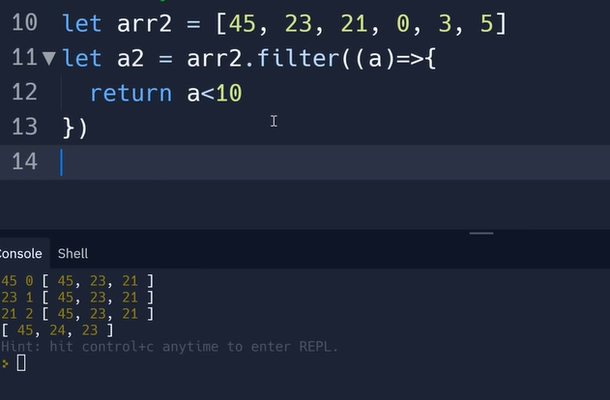

Reduce

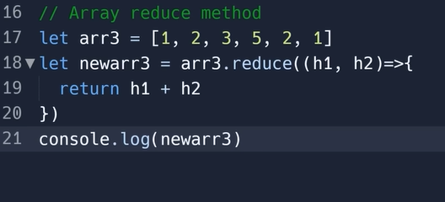

You can also use a function here

And remember Map and Filter returns a new array and Reduce returns a value

